

|  |
| --- |
| FusionInvest |
| Workflow Selector Condition – Is Delegate |
|  |

|  |
| --- |
|  |

Contents

1. Purpose 2

2. Document Control 2

3. Requirements 3

3.1 Functional Requirement 3

3.2 Identifying Delegate Trades 3

# Purpose

The purpose of this document is to specify the technical requirements for a workflow selector condition to identify any Delegate trades.

# Document Control

|  |  |  |  |
| --- | --- | --- | --- |
| **Date** | **Version** | **Author** | **Comments** |
| **25-10-17** | 1.0 | James Singleton | Initial draft |
|  |  |  |  |

# Requirements

## Functional Requirement

Whenever a transaction is booked in Fusion we need to accurately identify if it is a Delegate trade or not. We can then use this information in the Workflow Selector to correctly route Delegate trades to the associated Delegate workflow.

The resulting condition should be called ‘**Is Delegate**’ and appear as an option in the Condition (1, 2 or 3) column of the Selector:

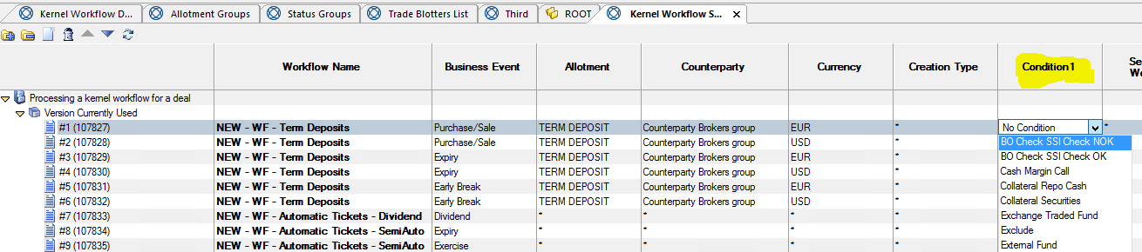

## Identifying Delegate Trades

Within the portfolio structure there is normally a portfolio named ‘MAML’ within each ‘Investments’ portfolio. For example:

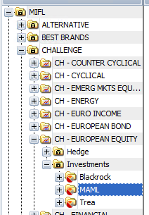 - or - 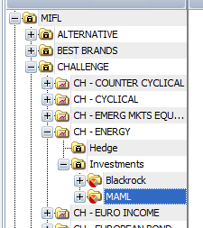

Whenever a transaction is booked and the system checks the workflow selector to determine the workflow, we need a toolkit to check whether the portfolio ‘MAML’ exists anywhere in the entire booked hierarchy.

Note the transaction could be booked further down the portfolio hierarchy therefore the toolkit needs to check all the parent portfolios for the existence of ‘MAML’.

In the example below the transaction could be booked under the following hierarchy:

-CHALLENGE

-CH – EUROPEAN EQUITY

-Investments

-**MAML**

-MAML Cash

-Cash

* Transaction

Therefore the toolkit would need track up in the portfolio structure from ‘Cash’ to ‘MAML Cash’ to ‘MAML’ in order to assess the condition.

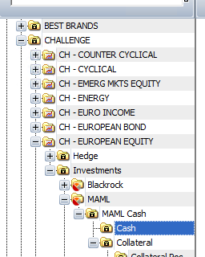

The logic when checking all the parent portfolios should be:

If portfolio ‘MAML’ is found:

* The ‘Is Delegate’ condition **IS NOT** satisfied

If portfolio ‘MAML’ is not found, i.e. it could be ‘Blackrock’, ‘Trea’ or indeed anything else:

* The ‘Is Delegate’ condition **IS** satisfied.

